Riddhi Pratim Das Superset ID - 6361832

React Hands-On Exercises Solutions

Lab 1

LAB 1 Code -

/App.js

import React from 'react';
function App() {
return (
<div className='full'>
<h1>Welcome to the first session of React</h1>
<h3>Riddhi Pratim Das - 6361832</h3>
</div>
);
}
export default App;

LAB 1 Output -

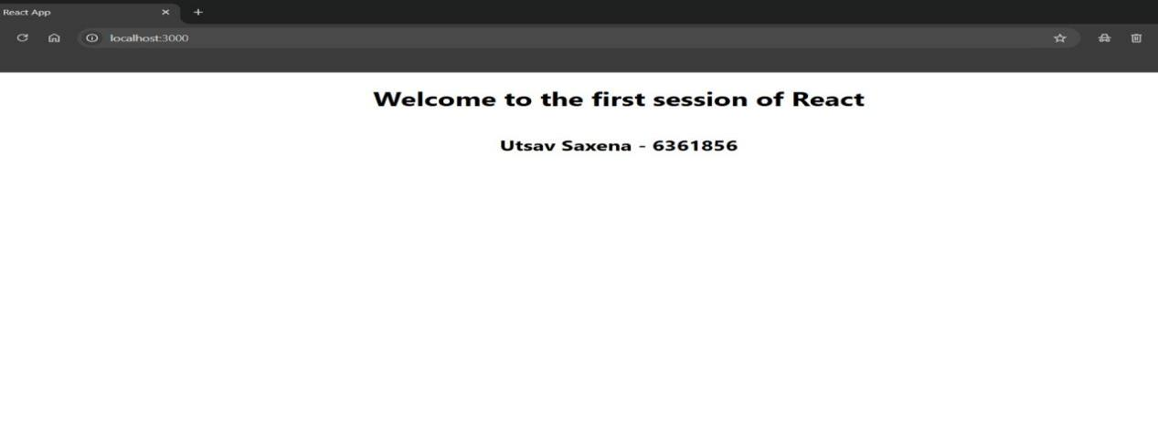

Lab 2

LAB 2 Code -

/App.js

import React, { Component } from 'react';
import './App.css';
import Home from './Components/Home';
import About from './Components/About';
import Contact from './Components/Contact';

class App extends Component {
render() {
return (
<div className="container">
<Home />
<About />
<Contact />
</div>
);
}
}
export default App;

/Components/Home.js

import React, { Component } from 'react';
class Home extends Component {
render() {
return (
<div>
<h3>Welcome to the Home page of Student Management Portal</h3>
</div>
);
}
}
export default Home;

/Components/About.js

import React, { Component } from 'react';
class About extends Component {
render() {
return (
<div>
<h3>Welcome to the About page of the Student Management Portal</h3>
</div>
);
}
}
export default About;

/Components/Contact.js

import React, { Component } from 'react';
class Contact extends Component {
render() {
return (
<div>
<h3>Welcome to the Contact page of the Student Management Portal</h3>
</div>
);
}
}
export default Contact;

LAB 2 Output -

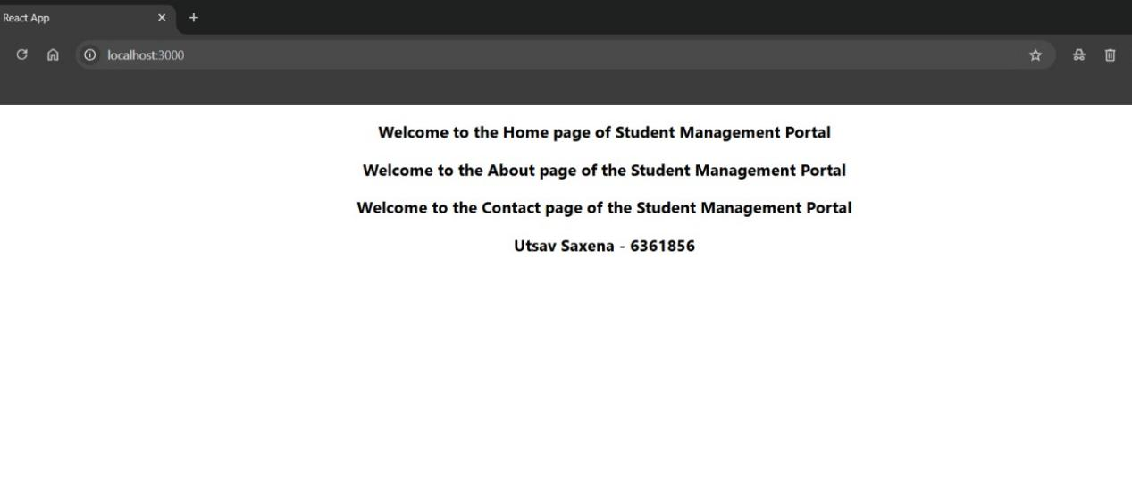

Lab 3

LAB 3 Code -

/CalculateScore.js

import React from 'react';
const percentToDecimal = (decimal) => {
return (decimal * 100).toFixed(2) + '%';
};
const calcScore = (total, goal) => {
return percentToDecimal(total / goal);
};
export const CalculateScore = ({ Name, School, total, goal }) => (
<div className="formatstyle">
<h1><font color="Brown">Student Details:</font></h1>
<div className="Name">
<b><span>Name: </span></b> <span>{Name}</span>
</div>
<div className="School">
<b><span>School: </span></b> <span>{School}</span>
</div>
<div className="Total">
<b><span>Total: </span></b> <span>{total}</span> <span>Marks</span>
</div>
<div className="Score">
<b>Score: </b> <span>{calcScore(total, goal)}</span>
</div>
</div>
);

/App.css

.Name {
font-weight: 300;
color: blue;
}

.School {
color: crimson;
}

.Total {
color: darkmagenta;
}

.formatstyle {
text-align: center;
font-size: large;
}

.Score {
color: forestgreen;
}

/App.js

import React from 'react';
import { CalculateScore } from './Components/CalculateScore';
import './App.css';
function App() {
return (
<div>
<CalculateScore
Name="Riddhi Pratim Das"
School="KIIT University"
total={450}
goal={500}
/>
</div>
);
}
export default App;

Lab 4

LAB 4 Code -

/App.js

import React from 'react';
import { Posts } from './Post';

function App() {
return (
<div>
<Posts />
</div>
);
}

export default App;

/Post.js

import React from 'react';

class Posts extends React.Component {
constructor(props) {
super(props);
this.state = {
posts: []
};
}

loadPosts() {
fetch('https://jsonplaceholder.typicode.com/posts')
.then(response => response.json())
.then(data => {
this.setState({ posts: data });
});
}

componentDidMount() {
this.loadPosts();
}

componentDidCatch(error, info) {
alert('An error occurred: ' + error.toString());
}

render() {
return (
<div>
<h1>Blog Posts</h1>
{this.state.posts.map(post => (
<div key={post.id} style={{ marginBottom: '20px' }}>
<h3>{post.title}</h3>
<p>{post.body}</p>
</div>
))}
</div>
);
}
}

class Post {
constructor(id, title, body) {
this.id = id;
this.title = title;
this.body = body;
}
}

export default Post;
export { Posts };

LAB 4 Output-


Lab 5

LAB 5 Code -

/CohortDetails.js

import React from 'react';
import styles from './CohortDetails.module.css';
function CohortDetails(props) {
const status = props.cohort.currentStatus.toLowerCase();
const titleStyle = {
color: status === 'ongoing' ? 'green' : 'blue'
};

return (
<div className={styles.box}>
<h3 style={titleStyle}>
{props.cohort.cohortCode} - <span>{props.cohort.technology}</span>
</h3>
<dl>
<dt>Started On</dt>
<dd>{props.cohort.startDate}</dd>
<dt>Current Status</dt>
<dd>{props.cohort.currentStatus}</dd>
<dt>Coach</dt>
<dd>{props.cohort.coachName}</dd>
<dt>Trainer</dt>
<dd>{props.cohort.trainerName}</dd>
</dl>
</div>
);}
export default CohortDetails;

/CohortDetails.module.css

.box {
width: 300px;
display: inline-block;
margin: 10px;
padding: 10px 20px;
border: 1px solid black;
border-radius: 10px;
}

dt {
font-weight: 500;
}

‘LAB 5 Output-

